Forearm circumference/lengths finding:

Fingertip to wrist measurement on left hand:
- If using two parallel planes - 0.1232 m
- If going from centre of wrist to tip of middle finger - 0.12786 m (using this)

https://hypertextbook.com/facts/2006/bodyproportions.shtml - suggests 1.715 as ratio of forearmhand to forearm through study, but hand x ~1.4 = forearm length = 0.179 m

General belief stated in above hyperlink is that 1.6 is ratio of forearm-hand → 0.2046 m

Distance between middle finger tip and elbow as shown in figure 2.... | Download Scientific Diagram - looks dodgy

Overall dimensions of the arm-hand system. The effective length of the... | Download Scientific Diagram - 1.326 ratio, forearm length = 0.1695 m

https://www.researchgate.net/publication/336159306_Correlation_of_Forearm_Circumference_and_Hand_Length_with_Grip_Strength_in_Healthy_Young_Adults
Gets ratio of length to circumference of 1.34

Forearm circumference and forearm length:
Average Forearm Size (Circumference) for Men and Women - 27 to 31 cm circ ~ 29 cm circumference, 26.7 cm length RATIO: 1.086

Alex method:
If you could assume that his left hand length is approximately his palm length + normal person's first finger segment length, then you can use this table to figure out what the length of his next 2 digits would be if he had them, and sum them to find what length of his "full hand" would be.

These are proportional dimensions btw.
Metacarpal > Palm bone that runs straight from wrist to start of 1st segment of digit
Proximal > 1st Segment of digit
Intermediate > 2nd
Distal > 3rd

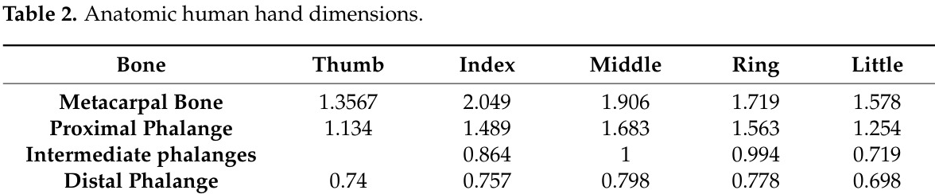
Using middle finger
Ratio of (1.906 palm length) to (1.683+1+0.798) → 1.826
(0.08046 m - 0.022 m palm length) makes finger length 0.107 m
Total hand length (from wrist connection to hand to tip of middle finger)= 0.1872 m

Using ratio of hand length to forearm length of 1.4, forearm length = 0.262 m
Forearm circumference = 1.086 x forearm length = 0.2846 m

